PIONEER JUNIOR COLLEGE: 2010 H2 Chemistry Preliminary Examinations
Paper 2: Suggested Answers

1 | (a) |  | (i) |  |  | pV  p  N₂  NH₃
 |  |  | (ii) |  |  | 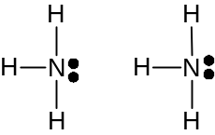  δ+ δ- δ+ δ-  |||||||
 |  |  | (iii) |  |  | - hydrogen bond between NH₃ molecules  - inter-molecular forces of attraction is not negligible
 |  |  | (iv) |  |  | pV = nRT ⇒ pV = (m/M_{r})RT  pM_{r} = (m/V)RT = ρRT  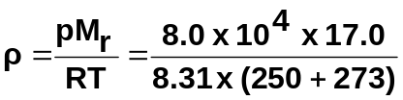 ⇒ ρ = 313 g m⁻³
 | (b) |  | 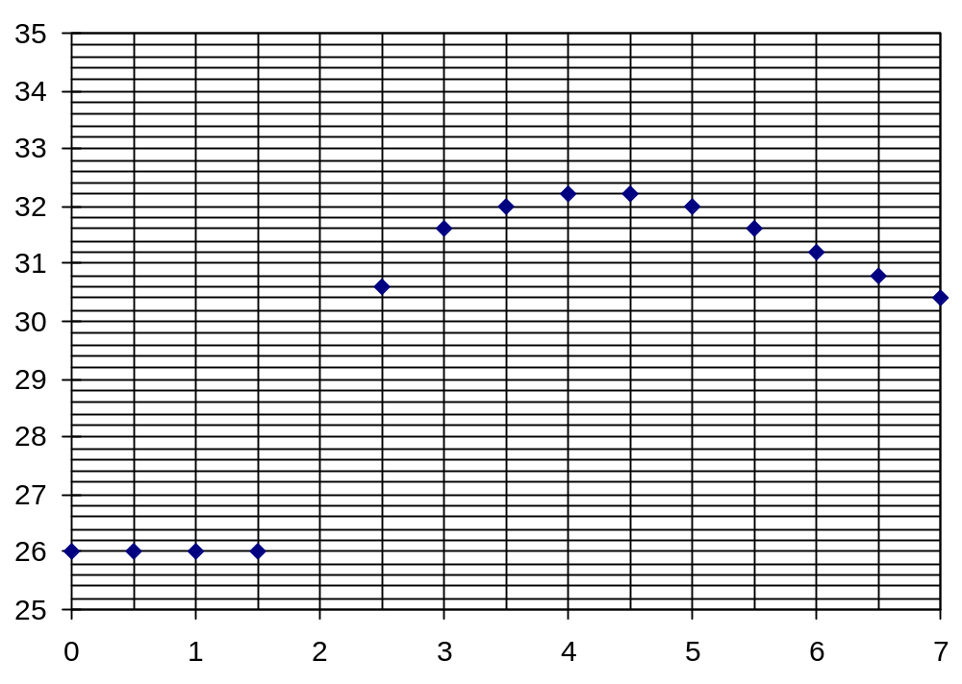  Temperature / ºC  Time / min  Maximum temperature change of reaction [for part (b)(ii)]
 |  |  | (i) |  |  | ammonia is a weak base, does not dissociate completely
 |  |  | (ii) |  |  | (from dotted line added onto the graph)  34.4 – 26.0 = 8.4 ºC
 |  |  | (iii) |  |  | 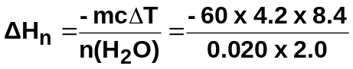  = – 52920 J mol⁻¹  = – 52.9 kJ mol⁻¹ (to 3 sf)
 |  |  | (iv) |  |  | - ethanoic acid is a weak acid, only dissociates partially  - CH₃CO₂H ⇌ CH₃CO₂⁻ + H⁺  during neutralisation, the O-H bonds break  - some energy is absorbed for the bond breaking process which is endothermic
 | (c) |  | 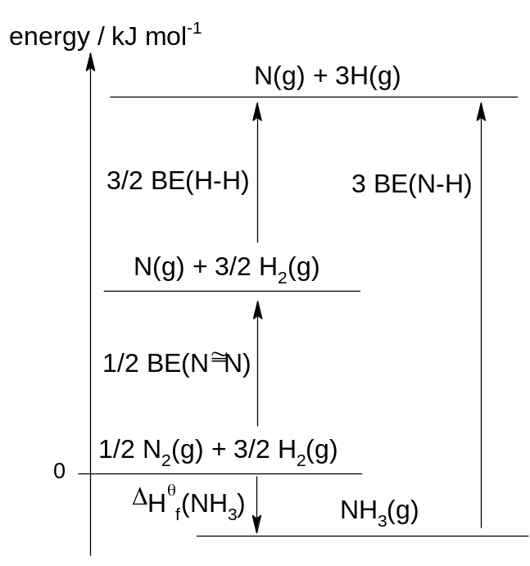  By Hess’ Law,  3BE(N-H) = 3/2BE(H-H) + 1/2BE(N≡N) – ∆H^{θ}_{f}(NH₃)  = 3/2(436) + 1/2(994) – (-46) = 1197  BE(N-H) = 1197 / 3 = 399 kJ mol⁻¹
2 | (a) |  | (i) |  |  | rate ∝ 1/time
  experiment | [H⁺] = [I⁻] = 0.500 mol dm⁻³
  experiment | [H₂O₂] / mol dm⁻³ | time / s | rate
  1 | 0.004 | 74 | 0.0135
  2 | 0.006 | 49 | 0.0204
  3 | 0.008 | 37 | 0.0270
  4 | 0.010 | 30 | 0.0333
  5 | 0.012 | 25 | 0.0400
 |  |  | (ii) |  |  | 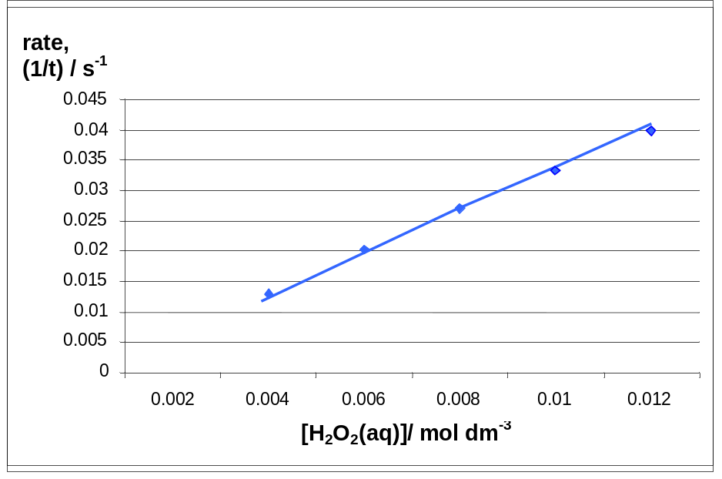
 |  |  | (iii) |  |  | first order, because the graph is upward-sloping / straight line with positive gradient / rate is proportional to [H₂O₂]
 |  |  | (iv) |  |  | So that the concentration of I⁻ and H⁺ remain relatively constant (OR change in concentration of I⁻ and H⁺ is negligible) throughout the experiment. Hence, any change in the time taken for deep blue colour to appear is solely due to H₂O₂.
 | (b) |  | (i) |  |  |  | Total volume is constant so that volume of reactant is directly proportional to the concentration of reactants.
 |  |  | (ii) |  |  |  | Comparing experiment 1 and 2, [H₂O₂] and [H⁺] are constant,  [I⁻] doubles, time taken for colour to change is approximately halved / rate doubled.  ∴ order of reaction with respect to I⁻ = 1 or rate ∝ [I⁻]
 |  |  | (iii)
  Expt | Volume / cm³ |  |  |  |  |  | Time / s
  Expt | 0.10 M H₂O₂ | 1.00 M KI | 0.10 M HCl | 0.10 M Na₂S₂O₃ | starch | water | Time / s
  1 | 5 | 10 | 10 | 2 | 3 | 70 | 100
  2 | 5 | 20 | 10 | 2 | 3 | 60 | 48
  3 | 5 | 20 | 5 | 2 | 3 | 65
 | (c) |  | A catalyst increases the rate of a chemical reaction by providing an alternative reaction pathway with a lower activation energy.  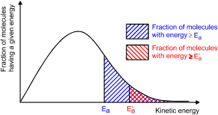  E_{a,catalysed} is lower than E_{a,uncatalysed} and, fraction of particles with energy ≥ E_{a,catalysed} increases.  Frequency of effective collisions increases.  Rate of reaction increases.
3 | (a) |  | (i) |  |  |  | Across period 3,  - increase in nuclear charge due to increase in number of protons.  - screening effect is approximately constant as the number of inner filled quantum shells remains the same.  - effective nuclear charge increases / stronger electrostatic attraction between the nucleus and valence electrons.  - more energy required to remove outermost / valence electron
 |  |  | (ii) |  |  |  | Chlorides hydrolyse in water to form acidic solutions of HCl.  SiCl₄(l) + 2H₂O(l) → SiO₂(s) + 4HCl(aq)
 |  |  | (iii) |  |  |  | AlCl₃ first dissolves to form [Al(H₂O)₆]³⁺ion.  AlCl₃(s) + 6H₂O(l) → [Al(H₂O)₆]³⁺(aq) + 3Cl⁻(aq)  Al³⁺ has high charge density / polarising power. Al³⁺ polarises surrounding coordinated H₂O molecules and weakens the O-H bonds, causing them to release H⁺ ions.  [Al(H₂O)₆] ³⁺(aq) → [Al(H₂O)₅(OH)]²⁺(aq) + H⁺(aq)
 | (b) |  | (i) |  |  |  | Ca(NO₃)₂(s) → CaO(s) + 2NO₂(g) + ½O₂(g)
 |  |  | (ii) |  |  |  | 1. CaO(s) + H₂O(l) → Ca(OH)₂(s)  2. CaO(s) + H₂O(l) → Ca(OH)₂(aq) OR Ca²⁺(aq) + 2OH⁻(aq)  Ca(OH)₂(aq) + CO₂(g) → CaCO₃(s) + H₂O(l)  A white precipitate of CaCO₃ is observed on bubbling in carbon dioxide.
 | (c) |  | XCO₃(s) → XO(s) + CO₂(g)  Amount of CO₂ = 1.25/44.0 = 0.0284 mol  Amount of XCO₃ = 0.0284 = 4.19/M_{r} of XCO₃  M_{r} of XCO₃ = 147.5  147.5 = A_{r} of X + 12.0 + 3(16.0)  A_{r} of X = 87.5  X is strontium.
4 | (a) |  | (i) |  |  |  | 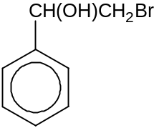
 |  |  | (ii)
  step | reagents and conditions
  I | K₂Cr₂O₇(aq), H₂SO₄(aq), heat
  II | KMnO₄(aq), H₂SO₄(aq), heat
  III | excess concentrated H₂SO₄, 170 ºC
  IV | concentrated HNO₃, concentrated H₂SO₄, 30 ºC
 | (b) |  | Glu  Phe  His  anode (+)  cathode (–)
 | (c) |  | (i) |  |  |  | The tertiary structure of a protein is the three dimensional structure / conformation of the polypeptide where the secondary structure and the unstructured length of peptide devoid of secondary structure is held by interactions between the side chain groups.
 |  |  | (ii) |  |  |  | phe contains a non-polar benzene group that will form van der Waals’ forces of attraction while thr has a –OH group that can participates in hydrogen bonding.  As the strength of hydrogen bonds is stronger than van der Waals’ forces, the change in the side chain groups can cause the folding / conformation of the enzyme to differ.
 | (d) |  | (i) |  |  |  | 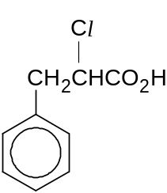
 |  |  | (ii) |  |  |  | excess concentrated NH₃ in ethanol, heat in sealed tube
 |  |  | (iii) |  |  |  | optical isomerism
 |  |  | (iv) |  |  |  | nucleophilic addition  HCN + NaOH → NaCN + H₂O  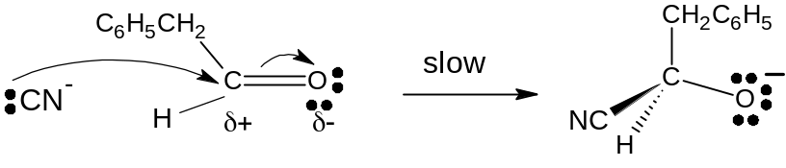  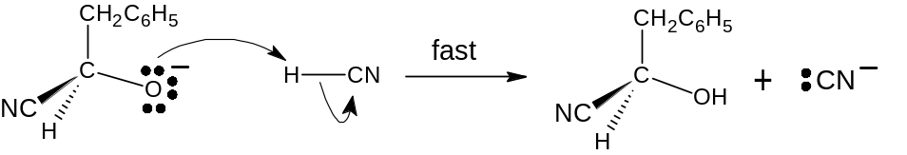
 |  |  | (v) |  |  |  | As the reaction involves a carbocation intermediate which has a trigonal planar geometry about the C with the positive charge. CN⁻ has equal likelihood of attacking on either side of the planar, resulting in the formation of a racemic mixture which has equimolar quantities of the two enantiomers. Thus, the optical activity is cancelled out.
5 | (a)
  Reagents | Observations
  aqueous sodium / potassium thiocyanate OR NaSCN(aq) / KSCN(aq) | blood red solution / complex formed
  aqueous phenol / C₆H₅OH(aq) | violet / purple complex / solution formed
  NaCN(aq) / KCN(aq) | orange-brown ppt formed
  NaOH(aq) / KOH(aq) / NH₃(aq) | reddish-brown ppt formed, insoluble in excess
 | (b) | (i)
CH₃CH(OH)CH₂CH₃ CH₃CH₂CH₂CHO CH₃COCH₂CH₃

Test 1: Using droppers, place 1 cm³ of each unknown in separate test tubes. Using a dropper, add 2 cm³ of Tollens’ reagent to each test tube. Shake well. Heat the test tubes in a hot water bath for 5 minutes.

No silver mirror formed.
Silver mirror formed.

CH₃CH₂CH₂CHO
CH₃CH(OH)CH₂CH₃ CH₃COCH₂CH₃

Test 2: Using droppers, place 1 cm³ of each unknown in separate test tubes. Using a dropper, add 2 cm³ of 2,4-DNPH to each test tube. Shake well.

Orange ppt seen.
No orange ppt.

CH₃COCH₂CH₃
CH₃CH(OH)CH₂CH₃

Test 3: Using a dropper, place 1 cm³ of the unknown in a test tubes. Using a dropper, add 2 cm³ of I₂(aq) to the test tube. Using a dropper, add aqueous NaOH dropwise with shaking until the brown colour just disappears. Heat the test tube in a hot water-bath for 5 minutes.

Yellow ppt of CHI₃ seen.

 |  | (ii) |  |  | - (if oxidation is performed) Butan-2-ol needs to be identified before butanal since both can be oxidised, or vice-versa.  - (if tri-iodomethane test is performed) Butan-2-ol needs to be identified before butanone since both give yellow ppt, or vice-versa.  - (if 2,4-DNPH is used) Butanal needs to be identified before butanone since both give an orange ppt, or vice-versa.  - (if sodium is used) Ensure the unknowns are anhydrous, as water can react with sodium metal to give a false positive test.  [any one]
 | (c) | - Compounds like butan-2-ol, butanal and butanone are inflammable / flammable. Ensure no naked flame is used and a water bath is used for heating.  - Compound like butan-2-ol, butanal and butanone are volatile and toxic. Perform experiment in a fume cupboard to minimise fumes inhaled.  - Compound like butan-2-ol, butanal and butanone is toxic (and corrosive). Use test tube holder, add chemicals using droppers, wear gloves and goggles to avoid direct contact with chemicals.  - (if sodium is used) Hydrogen gas is explosive. Ensures absence of naked flame / only used a small piece of sodium metal OR ensure anhydrous condition for sodium. (award only once in (b)(ii) or (c).)  [any 2, reject precaution without reason]

